Html Landing page creation prompt for VScode – Hemels Café

CONTEXT of the BUSINESS

can you give me a description of this coffee shop that i can use for my html landing page builder prompt? here are a few links:
https://www.instagram.com/hemelscafe/
https://www.facebook.com/p/Hemels-Caf%C3%A9-100083037535228/
https://hemels-cafe.placejoys.com/

give me suggestions I can use for the prompt for a landing page that will stand out from competitors, highlighting their strengths. Use the following sections to fill out, and add in whatever else you think is relevant to aid conversion on this landing page.:
BUSINESS DETAILS

Name:
Hemels Cafe

Location:
Green Grove, Lynnwood Rd Portion 158 of the farm The Willows 340 J.R, Wapadrand, Pretoria, 0050
Business type:
Independent local coffee shop

Primary goal:
Grow Instagram following, increase foot traffic, email subscribers, and repeat customers.

Secondary goals:
Position Hemels Cafe as a tranquil, Self-service concept destination and independent coffee shop with good coffee, beautiful outdoor areas, and country community character.

BRAND POSITIONING

VISUAL DIRECTION
Use:

Avoid:

INTERIOR CONTEXT

GOOGLE REVIEWS

I will paste Google reviews below.

Analyse the reviews to identify:
- strongest trust signals
- repeated customer praise
- emotional buying reasons
- recurring wording customers naturally use
- proof points
- objections the page should overcome
- reasons people return
- SEO phrases
- AI-search-friendly phrasing

Use the reviews to extract and own a clear positioning angle for the brand. The website should feel like it knows exactly what it is, who it is for, and what makes it different.

Google reviews:

Macaela Vermeulen
Local Guide·98 reviews·357 photos

8 months ago
Brunch | R 100–200
Hemels Café is pure serenity tree-shaded lawns, gorgeous white architecture, outstanding coffee, cheesecake and sandwiches. Pet, kid and wheelchair friendly with charming local gifts… heavenly. ☕🌳✨ …More
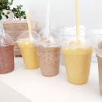
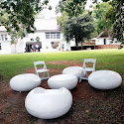
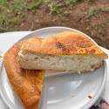
🙏1

Sara Lubis
Local Guide·416 reviews·2422 photos

a year ago
Dine in | Other | R 100–150
An aesthetic, chic café in Pretoria East.
Loving the fact that it's located on the main road, but the place was quiet and …More
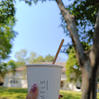
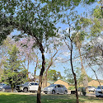
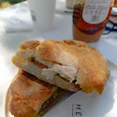

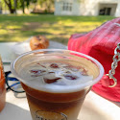
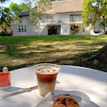
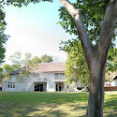
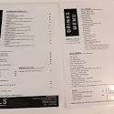
❤️3
Hemels Café (owner)
a year ago
Thank you Sara for this very thorough and thoughtful review. We appreciate you!

Life with Substance
Local Guide·9 reviews·19 photos

8 months ago
Breakfast | R 100–200
The place is very clean and quiet ! Absolutely loved the barista and how kind he was . …More
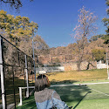
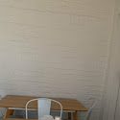
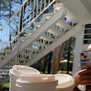
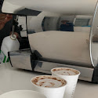
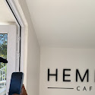
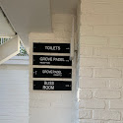
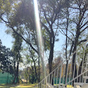
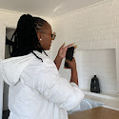
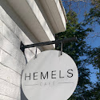
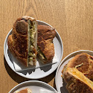
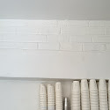
😋1

Kane Laka
Local Guide·134 reviews·489 photos

2 years ago
Dine in | Other | R 50–100
A friend and I went out for coffee. It’s so tranquil and was right behind our back yard. The white buildings and open areas stand out. Ordered cheese cake.. Twas a good day out… ample space for parking. The place is wheelchair friendly. …More
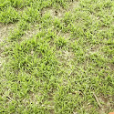
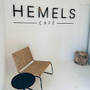
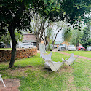
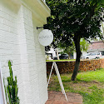
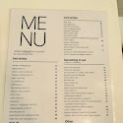
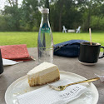
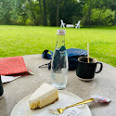

Patricia Mutambayi
Local Guide·47 reviews·34 photos

5 months ago
R 100–200
Friendly staff, beautiful scenery, so much to do and eat ! What’s not to love !
Price per person: …More
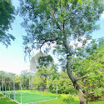
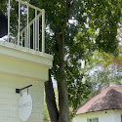
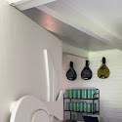
❤️1

Sonja Wilken
Local Guide·11 reviews·5 photos

a year ago
R 50–100
Such a calm and relaxing space. My fiancée and I met up with a friend at this hidden gem 💎 of a spot. As restaurant managers ourselves we always look for a calm and relaxing space to enjoy time with friends. We will absolutely be coming …More
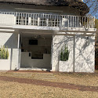
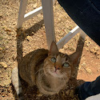

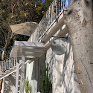

Kgalaletso seemise
Local Guide·13 reviews·55 photos

a year ago
Dine in | Breakfast | R 100–150
This charming spot is ideal for coffee dates! The cheesecake is truly exceptional - perfectly baked with a delightful blend of flavors. As a chai latte enthusiast, I was thoroughly impressed with their version. However, if you're not a cat …More
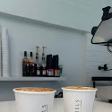
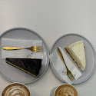
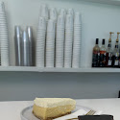
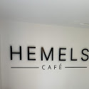
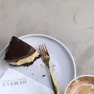
❤️2
Hemels Café (owner)
a year ago
Thank you for this kind review! We appreciate the feedback and will pass it on to our team.

Maryke Fritz
Local Guide·208 reviews·1596 photos

2 years ago
Delicious coffee made with a smile! The barista will make the coffee exactly like you want and give suggestions as to what you may like. They really made our day. Beautiful scenery and I think it will be even more splendid in the summer. We …More
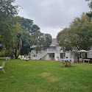
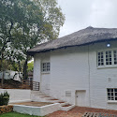
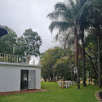
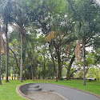
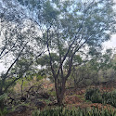

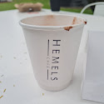
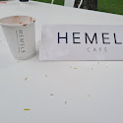
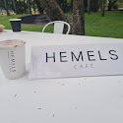

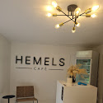
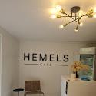
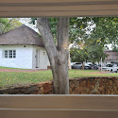
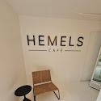
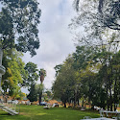
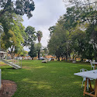
Hemels Café (owner)
2 years ago
Wow thank you Maryke for the very generous review! We are glad you enjoy our staff, our coffee and scenery. Hope to see you again very soon!

Boitumelo “Tumi”
6 reviews·7 photos

a year ago
Always a great time being here, greeted by Thandi’s radiant smile. Super friendly staff and barristers. The cafe is really charming while the garden & amenities are well maintained. Highly recommend stopping by.


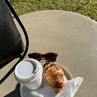
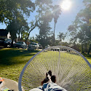
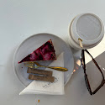
❤️2

L B
Local Guide·148 reviews·493 photos

a year ago
Dine in | Lunch | R 200–250
Love Hemels. I’ve been a few times, food and coffee quality are top tier. Staff is really great too. The environment is great for a relaxed coffee date. …More
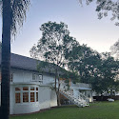
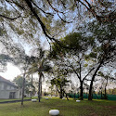

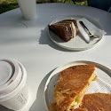

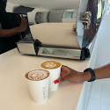
❤️3
Hemels Café (owner)
a year ago
Thank you very much for this kind review. We hope to see you again 🌿

Hannah Sergeant
Local Guide·27 reviews·70 photos

2 years ago
Dine in | Other | R 50–100
Absolutely beautiful coffee shop! Very pleasant experience with the friendliest staff that made my friends and I laugh and were very accommodating. I will definitely go back :) aesthetic environment and you can also find some cute …More

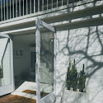
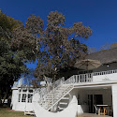
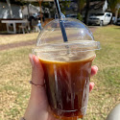
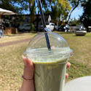
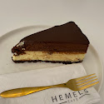

❤️2

Xander
Local Guide·59 reviews·69 photos

2 years ago
Dine in | Breakfast | R 100–150
The perfect cafe to go to if you want to escape the busyness of Pretoria for a short moment. The cafe is set back away from the main road, and seating is spread out far enough to ensure conversations feel private and everyone can enjoy the …More
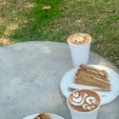
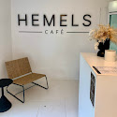
❤️2

Claudia Bianca
Local Guide·22 reviews·87 photos

2 years ago
Dine in | Brunch | R 50–100
Ah, the chocolate cake at Hemels Cafe is a slice of pure indulgence. Moist, decadent, and rich in flavor, it's a dessert lover's dream come true. Each bite is a heavenly experience, with layers of velvety chocolate goodness that melt in …More

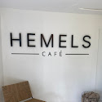
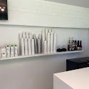
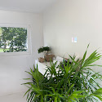
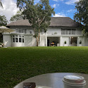
❤️2
Hemels Café (owner)
a year ago
Thank you dearest Claudia. This review means a lot!

Ioanna Piagalis Oriental Invasion
Local Guide·4 reviews·49 photos

3 years ago
Dine in | Brunch | R 50–100
Lovely coffee spot on Lynnwood road.
Sip your brew (made by Julius) amongst the trees in the shade whilst listening to the birds. …More
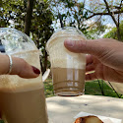
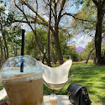

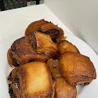
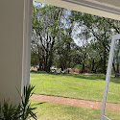
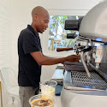
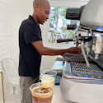
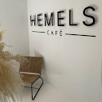
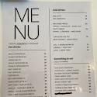
❤️1
Hemels Café (owner)
3 years ago
⭐️⭐️⭐️⭐️⭐️

Lesego Marobe
Local Guide·22 reviews·47 photos

2 years ago
Dine in | Brunch | R 150–200
The most serene and scenic coffee shop I have ever been to. The food is so delicious wow,I had cheese cake and their beef soup. I really loved the ambience of this place. The service was excellent 👌. The waiters are so friendly and …More
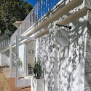
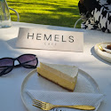
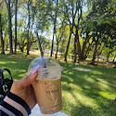
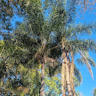
Hemels Café (owner)
2 years ago
Thank you so much Lesego. This review means a lot to us and our team. We appreciate it and hope to see you again soon.

Bongs Ndlela
Local Guide·132 reviews·1516 photos

a year ago
Dine in | Brunch | R 100–150
This place is nice and quiet, with a huge garden and tennis court. I enjoyed coming here. …More
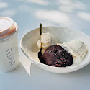
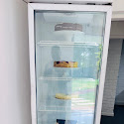
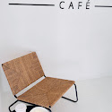
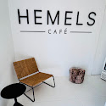
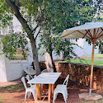
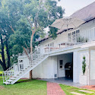
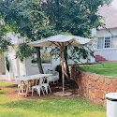
❤️2

Michaene Olivier
3 reviews·1 photo

2 years ago
Dine in | Lunch | R 100–150
Our entire experience at Hemels Café since the moment we arrived was amazing. The staff was unbelievably friendly and the service was great! Not to mention the food which was incredibly tasty - I would definitely recommend the Créme Brulee …More
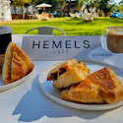
Hemels Café (owner)
2 years ago
Thank you so much for this very kind review. We love serving our customers and offering a relaxing experience. We are glad you enjoyed your visit. See you again soon!

Kathleen Godfrey
Local Guide·114 reviews·94 photos

2 years ago
Dine in | Other | R 50–100
A lovely little location for a calm day. Lovely coffee and drink options. For those without dietary requirements, I'm told the cheesecake is amazing, and so are the sandwiches and brownies. …More
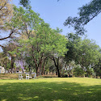
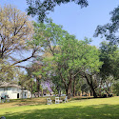
Hemels Café (owner)
2 years ago
Thank you Kathleen, for your lovely review. We hope to have some gluten free options in the future ☕️

Schalk Uys
Local Guide·216 reviews·5574 photos

a year ago
Dine in | Brunch | R 150–200
Lovely tranquil place under big trees with green grass. The sandwiches are delicious and coffee good. …More
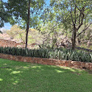
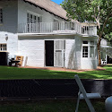
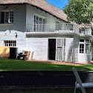
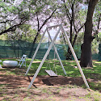
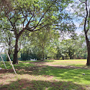
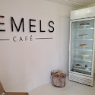
❤️2
Hemels Café (owner)
a year ago
Thank you Schalk! We appreciate you taking the time to review our beloved Hemels.

Chelsi Alexander
3 reviews·10 photos

a year ago
Dine in | Brunch | R 100–150
Great spot to relax and drink a cup of coffee while getting your car washed. Had wonderful service from Thandi. And would highly recommend the Chorizo ciabatta. …More
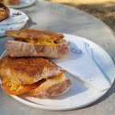
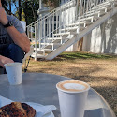
❤️3
Hemels Café (owner)
a year ago
Thank you Chelsi! We appreciate you taking the time to review!

Shalom P
Local Guide·123 reviews·278 photos

2 years ago
Dine in | Other | R 50–100
I’ve been here twice already and on both occasions we had a lovely time. This is the perfect place to catch up with a friend and enjoy some time outdoors at the same time. …More
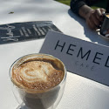
Hemels Café (owner)
2 years ago
Hi Shalom. Thank you very much for your review. We are glad to hear you enjoy your visits and looking forward to see you again soon!

Laura Neto
Local Guide·114 reviews·96 photos

3 years ago
What a sneaky little treat, really great atmosphere. Very relaxed! The staff are really friendly! Tastiest are delicious and the chocolate cake was extra delicious! Really nice place for kitchen tea/baby shower vibes …More
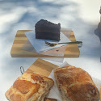
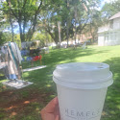
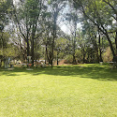
Hemels Café (owner)
3 years ago
Good day Ms Neto.
We’re ecstatic that you had a wonderful time. Thank you for your support! We highly appreciate your feedback and insight!

Tracy De Vries
Local Guide·8 reviews·1 photo

2 months ago
R 400–500
Its a lovely place to relax and enjoy chilled vibes for a late Saturday or sunday outing …More

Lebogang Bopape
4 reviews·1 photo

9 months ago
Other | R 250–300
I had such a great experience at Hemels Café Padel! I wanted to try something different from my usual gym routine today, and it turned out to be the perfect choice – I managed to burn 450 calories in just one game! A big thank you to Joseph …More


Lauren Erasmus
Local Guide·268 reviews·11651 photos

a year ago
Very beautiful venue
Padel tennis also available …More
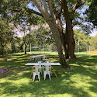
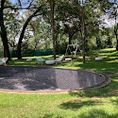
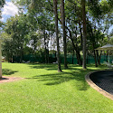
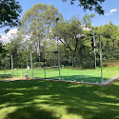
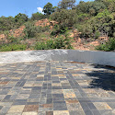
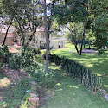
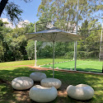
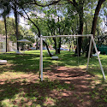
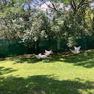
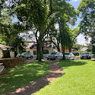
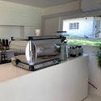
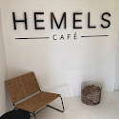
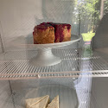
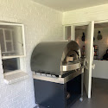
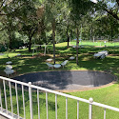
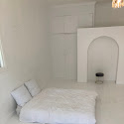
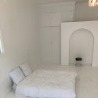
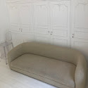
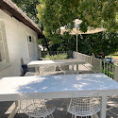
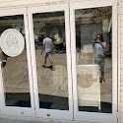
❤️1

Thandi siliga
Local Guide·66 reviews·10 photos

2 years ago
Amazing atmosphere and loved the ambiance. The coffee and cake were really good, wish they had a wider Menu range but overall great quiet, peace coffee shop. …More

❤️2
Hemels Café (owner)
2 years ago
Thank you Thandi! We sincerely appreciate your feedback.

Music man
Local Guide·30 reviews·1 photo

a year ago
Dine in
Very pleasant atmosphere, very tasty variety of Caibata sandwiches. Milkshakes nice and thick. I'll be back! …More
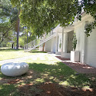
❤️2
Hemels Café (owner)
a year ago
Thank you for taking the time to write this thoughtful review. We hope to see you again!

Siphosihle Vincelia S
1 review·2 photos

a year ago
The customer service was excellent. By Itumeleng, Thandi and mos (I think that’s his name lol sorry). …More
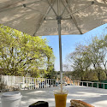

❤️2
Hemels Café (owner)
a year ago
Thank you for this kind review! We appreciate the feedback.

Bronwyn Van schalkwyk
Local Guide·62 reviews·335 photos

2 years ago
Dine in | Breakfast
Such a cute little place with great coffee and treats, wonderful atmosphere and the staff are friendly and very helpful …More

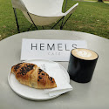
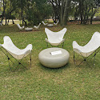
Hemels Café (owner)
2 years ago
Thank you so much Bronwyn! We appreciate the kind words and sure our staff will be very pleased to read this as well. Hope to see you again soon!

Carma Kriel
2 reviews

8 months ago
Had a wonderful babyshower at Hemels. Lowkey and easy to host - Thandi is such a helper. Wonderful coffee and beautiful location!

keitumetse
Local Guide·12 reviews·18 photos

2 years ago
Dine in | Lunch | R 50–100
If you are looking for a place to relax and be one with nature, this is the best place to be. It is affordable, spacious, comfortable and has the perfect customer service. …More
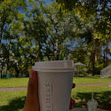
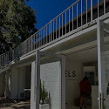

Lita Jacobs
3 reviews·7 photos

Edited 3 years ago
Awsome Venue, Delicious Coffee
Another awsome day at Hemels Café.
Thanks for the great service Julius
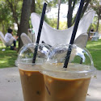
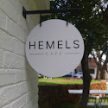

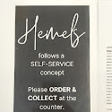



Hemels Café (owner)
3 years ago
Good day Mrs Jacobs!
Thank you for taking the time to review our Café.

Hanli Nel
Local Guide·33 reviews·11 photos

a year ago
Dine in | Other | R 100–150
What a lovely Gem! From freezos to cappuccinos, toasties to cakes! It all looked absolutely amazing!
Exceptional service from all staff. …More

❤️2
Hemels Café (owner)
a year ago
Thank you for this very kind review Hanli. We appreciate you!

Bianca Benadie
Local Guide·70 reviews·58 photos

3 years ago
AMAZING place, beautiful and peaceful. Best coffee and very friendly staff!!
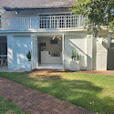
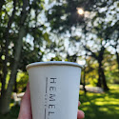
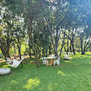
Hemels Café (owner)
3 years ago
Thank you very much for your kind review Bianca. We hope to see you again soon!

thiba Mokwena
Local Guide·83 reviews·80 photos

2 years ago
Dine in | Breakfast | R 100–150
Loved the place, for that Sunday coffee outing and chill. Lovely environment as well to relax, and listen to the taste of the beans 👌🏿 …More
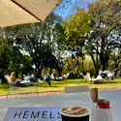
❤️1
Hemels Café (owner)
2 years ago
Thank you very much Thiba! We hope to see you again soon for a relaxing Sunday outing.

Maggie
Local Guide·13 reviews

5 months ago
Extremely friendly and helpful staff😁. Always a pleasure going there 🤍
❤️1

Shaen MacDevette
Local Guide·221 reviews·2315 photos

2 years ago
Dine in
This peaceful, relaxed and wholesome Cafe is a gem hidden away in the city. Open grass with tables under trees, places to picnic or under cover near the building. It's a self service system so you pay and takeaway to your table. They're …More
❤️2

Thuli Nkushubana
10 reviews

2 years ago
If you’re looking for a phenomenal place to celebrate a special event, look no further than Hemels Cafe. The atmosphere is warm and inviting, and the staff is friendly. …More
❤️2

Nadine van der Merwe
11 reviews

a year ago
Brunch | R 150–200
Since I discovered Hemels, I am literally there every month. I love the self-service concept and the nice outside space. My two year old loves the open grass and I enjoy the great coffee en calm atmosphere under the trees. …More
❤️2
Hemels Café (owner)
a year ago
Thank you so much for this very kind and thoughtful review Nadine. We are so happy to hear that you and kiddies are loving what we have to offer.

Clerisse Kriel
Local Guide·16 reviews·7 photos

2 years ago
Dine in | Other | R 100–150
Such a peaceful place for meetings or meeting up with a friend. As a photographer I like the combination of the studios with the café at the same premises. …More
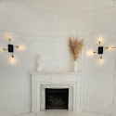
❤️2
Hemels Café (owner)
2 years ago
Thank you for this kind review! We love having you as a customer.

Kyle Preece
1 review

a year ago
Been a regular visitor at Hemels and can honestly say it’s my favourite coffee shop .
Very friendly staff and an awesome place to relax ! The padel courts there are a …More
❤️1

elzette le roux
Local Guide·41 reviews·90 photos

2 years ago
Despite arriving just before closing time, we were pleasantly surprised by the helpfulness of the staff. Their dedication and passion for their work truly shone through, and we're immensely grateful for their kindness. This charming …More
❤️2
Hemels Café (owner)
2 years ago
Aw wow thank you very much! We will be sure to tell our beloved staff about your kind words. Thank you for supporting Hemels café!

Refentse Sepeng
Local Guide·37 reviews·46 photos

10 months ago
R 200–250
Went there in the morning, enjoyed the atmosphere, it was nice and quiet and the food was also good. I ordered a chicken mayo ciabatta sandwich it was delicious, with a cappuccino. …More
❤️1

Madelyn
Local Guide·163 reviews·765 photos

a year ago
Dine in | Other | R 50–100
What a special place to find in a city!!! Although a busy street is close by you feel as if you are far away. You can hear the traffic but the trees and garden makes it very relaxing. Plenty of safe parking. Pet friendly with very friendly …More
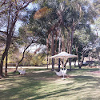
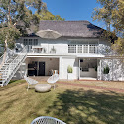

❤️3

Malesa Dimpho
3 reviews·5 photos

a year ago
This is the most heartwarming place I've ever been in,I highly recommend it 👍👍
Food: …More
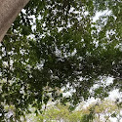

❤️2
Hemels Café (owner)
a year ago
Thank you so much Malesa. We appreciate your review 🌿

Alouise
Local Guide·85 reviews·193 photos

a year ago
Dine in | Brunch | R 100–150
Beautiful place
Incredible coffee ☕️
Insane toasted sandwiches 🥪 …More


❤️2

Juanita Beukman
Local Guide·119 reviews·57 photos

2 years ago
Great coffee.... great atmosphere ... Beautiful kitchen tea...
Atmosphere: …More
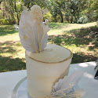
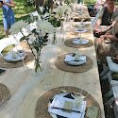
❤️2

Bianca Wolmarans
Local Guide·110 reviews·46 photos

2 years ago
Dine in | Lunch | R 100–150
We loved it here! Comfy chairs available for cosy coffee, picnic blankets for chilling under the trees, great selection of hot and cold beverages, yummy ciabata toasties and delicious-looking cakes. Will definitely be going back for the …More
❤️2
Hemels Café (owner)
2 years ago
Thank you so much Bianca. We appreciate your feedback!

Louise Steenkamp
1 review

a year ago
Enjoyed a beautiful birthday brunch at Hemel's Café! Thandi and her team were very helpful and friendly. Everyone will be dreaming about the cheesecake :)
❤️2

Nkamo Bucks
3 reviews·3 photos

a year ago
Breakfast | R 200–250
The best service, best people, great aesthetics and amazing customer service. Amazing amazing amazing place!!!! 😍 …More
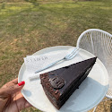

❤️2
Hemels Café (owner)
a year ago
Thank you for this kind review! We appreciate the feedback and will pass it on to our team.

Olufemi Akindele Olunloyo
Local Guide·408 reviews·4057 photos

4 months ago
Beautiful, peaceful and quiet amazing place
Food: …More
❤️1

Zanli Van der Merwe
Local Guide·39 reviews·19 photos

2 years ago
Dine in
A wonderful spot with lovely staff and the best coffee ☕.
Order type: …More
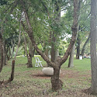
❤️2

Monique Van der Westhuizen
Local Guide·12 reviews·6 photos

2 years ago
Dine in | Brunch | R 100–150
Best white hot chocolate!
This cafe is truly a gem 😊🤍 …More
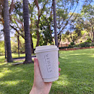
❤️2

Storm Ashlea
11 reviews·4 photos

2 years ago
Dine in | Other | R 50–100
Delicious coffee enjoyed under the trees. Would highly recommend.
Order type: …More
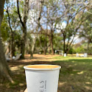

❤️2

khutjo mangope
3 reviews

a year ago
Dine in | Breakfast | R 50–100
What a beautiful place. The staff was friendly and all sorts of amazing. Thank you to Thandi & Martin. This is my new favorite spot. …More
❤️2

Rensche Fourie
4 reviews·1 photo

a year ago
Dine in | R 100–150
Friendliest staff. So helpful when I was ice cold. Most delicious Melkkos!!! Such a chill and relaxing vibe! …More
❤️2

Rudi Minty
Local Guide·28 reviews·22 photos

3 years ago
Takeaway | Other | R 1–50
My first visit to Hemels Cafe, and very pleased with an amazing cappachino! Looking forward to the menu expanding to include breakfast options since it's such a beautiful location. …More
Hemels Café (owner)
3 years ago
Thank you for your support and the wonderful review.

Emelda Rethabile
2 reviews

a year ago
Dine in | Breakfast
I was so very very impressed with Mr Manala's service❤️he gave us the best and we hoping to come back 🤭Thank you Manala keep it up👌 …More
❤️2
Hemels Café (owner)
a year ago
Thank you Emelda for the compliments and for acknowledging our staff. They sure love to be of service and we appreciate our team!

Janet West
Local Guide·45 reviews·1 photo

a year ago
Dine in | Other | R 1–50
Lovely place - such a nice atmosphere and such good service!!! Highly recommend this gem of a place!!! …More
❤️1

Daniélle Coetzee
Local Guide·10 reviews·2 photos

8 months ago
So peaceful here, and the coffee is great.
Food: …More

Monache van Rij
Local Guide·161 reviews·68 photos

2 years ago
Could use some more food options on the menu, but other than that, I can't recommend anything better! What a lovely visit and amazing coffee and cake! …More
❤️2
Hemels Café (owner)
2 years ago
Hi Monache! Thank you very much for your kind review. We are working hard to expand our options and offer more, but we are glad you had a pleasant experience. We hope to see you again soon!

Goodness Mamathi
2 reviews

a year ago
Good place to catch up with a friend or even some alone time. The place has good service and also cute aesthetics …More
❤️2
Hemels Café (owner)
a year ago
Thank you very much Goodness. We appreciate your review!

Lisa
Local Guide·82 reviews·252 photos

a year ago
Dine in | Breakfast | R 200–250
A true hidden treasure in Pretoria. Breakfast menu is innovative and the atmosphere is warm and welcoming. Would visit here again 😁 …More
❤️2

Tarryn Booysen
Local Guide·24 reviews

a year ago
Dine in | Brunch | R 100–150
Stunning hidden gem, with a lovely garden. Would definitely recommend for a quick coffee/light lunch. …More
❤️2

Brittny Crous
4 reviews·1 photo

3 years ago
Other
I love this place. I love the staff, they are more than friendly. I would definitely recommend this place to anyone. It is truly Hemels!!! Do yourself a favor and go and visit it!!! …More
Hemels Café (owner)
3 years ago
Wow thank you Brittny! We appreciate your kind review! Hope to have you again soon!

Melanie Swanepoel
3 reviews

3 years ago
Takeaway | Other | R 1–50
The best freezo’s and coffee in town.
Calm relaxing atmosphere… heaven on earth. Very friendly staff :-) …More
Hemels Café (owner)
3 years ago
⭐️⭐️⭐️⭐️⭐️

Luné Snyman
Local Guide·80 reviews·20 photos

a year ago
What a beautiful venue. And absolutely amazing coffee. Will definitely be back.
Service: …More
❤️2
Hemels Café (owner)
a year ago
Thank you for your kind review Luné 🌿

Albert Jacobs
Local Guide·59 reviews·35 photos

2 years ago
Dine in | Brunch | R 150–200
Lovely place and live music.
Order type: …More
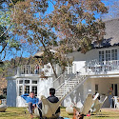
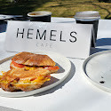
❤️2
Hemels Café (owner)
2 years ago
Thank you Albert. We appreciate your feedback.

Tsholanang Dinaka
4 reviews·1 photo

a year ago
Beautiful scenery, nice menu selections and super friendly staff
❤️3
Hemels Café (owner)
a year ago
Thank you so much for this kind review.

Khensani Makhubela
2 reviews

a year ago
Great customer service, lovely staff. Definitely returning to Hemels café
Food: …More
❤️1

marike bührmann
Local Guide·54 reviews·34 photos

4 months ago
Love the coffee and milkshakes!
❤️1

Neo Molomo
1 review

2 years ago
Thank you thandi and Martin... You gave us the best service ever.. Wil definitely come back.. Stay blessed ❤️ …More
❤️2
Hemels Café (owner)
a year ago
Thank you Neo for showing our staff all the love!

Beauty Beauty
1 review

a year ago
I enjoyed atmosphere mostly the barista is best and managed to give me all the info a girl needs🥰🥰🥰🥰♥️♥️♥️ …More
❤️2

Ofentse Lepaaku
1 review

a year ago
Dine in | Breakfast
Great service, the staff is friendly and always smiling. Keep up the good work.
Order type: …More
❤️2
Hemels Café (owner)
a year ago
Thank you for this kind review!

Jessica Mphahlele
1 review

a year ago
I had a good time with lovely staff so helpful thank you for your service🥰🥰🤩
Food: …More
❤️1

Moyahabo Maake
1 review

a year ago
Dine in | Lunch | R 100–150
So nice and quite place ...a good service .the environment is so fresh and clean …More
❤️3
Hemels Café (owner)
a year ago
Thank you very much for this thoughtful review.

Wisdom Tjikana
2 reviews

a year ago
Dine in | R 100–150
The service was amazing and food was scrumptious, you gained a new customer hey. …More
❤️2
Hemels Café (owner)
a year ago
Thank you for your review Wisdom.

Mrs B's Kitchen
Local Guide·19 reviews·1 photo

2 years ago
Stunning...tranquil...spacious...easy going atmosphere. Loved it! Great coffee...tasty sandwich.
❤️2
Hemels Café (owner)
2 years ago
Thank you very much for your kind review! We all appreciate it and hope to see you again soon in our Hemels garden.

Gabriella Rodrigues
3 reviews·3 photos

3 years ago
Dine in | Brunch | R 100–150
So quite and Tranquil. Friendly service and delicious coffee and treats. Would definately recomend for a morning out …More

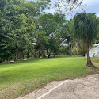

❤️1
Hemels Café (owner)
3 years ago
We totally agree!
Thank you for your positive review. We can’t wait to see you again.

Timarah McIntosh
5 reviews

3 years ago
Dine in | Brunch | R 50–100
Lovely place with a very chilled atmosphere. Such nice staff who are super friendly and helpful. …More
❤️1
Hemels Café (owner)
3 years ago
Thank you very much for your kind review!

Pieter Roelofse
1 review

3 years ago
It's absolutely perfect I love every thing about it.It is a 10 out of 10
Every thing is perfect.i love it.exelent service.every thing is delicious and cheap.It is perfect 10 out of 10
Hemels Café (owner)
3 years ago
Thank you Mr Roelofse for your review.

Mila Jacobs
2 reviews

3 years ago
The coffee was amazing and the place is so nice and beautiful I could spend the whole day here
❤️1
Hemels Café (owner)
3 years ago
Wow!
Love your review! We absolutely feel the same! Happy to host you! Can’t wait to see you again!

Lizzy Lekoto
3 reviews

a year ago
Dine in
Thanks for the best service Martin Manala we had a great time
Order type: …More
❤️2
Hemels Café (owner)
a year ago
Thank you Lizzy for reviewing our Hemels 🌿

Ankia Janse van Rensburg
2 reviews

a year ago
The Greek Ciabatta is my favourite!! Love it!
Food: …More

Chafay Van de Venter
3 reviews·1 photo

2 years ago
R 50–100
Beautiful and comfortable outside seating, friendly staff and great tea!
Price per person: …More
❤️2
Hemels Café (owner)
2 years ago
Thank you for this kind rating! We appreciate the support.

Carel van Rooyen
2 reviews

3 years ago
Dine in | Other | R 50–100
Hemels is such a peaceful spot with great coffee and even better cakes! 100% recommended 👌🏼 …More
❤️1
Hemels Café (owner)
3 years ago
Thank you very much for your kind review. We hope to see you again soon!

River & Reign Photography
4 reviews

Edited 3 months ago
Dine in | Breakfast | R 50–100
Lovely Café.
Great staff
Love Licht Studio …More
❤️1
Hemels Café (owner)
3 years ago
We’re happy that you now only enjoyed our coffee but also the scenery that surrounds the café.

Jabulani Cele
Local Guide·54 reviews·32 photos

a year ago
Grove Padel, leisurely playing
Food: …More
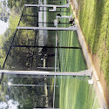
❤️1

Marianne Olivier
5 reviews

2 years ago
Excellent coffee, beautiful setting, great location for a quick coffee stop on Lynnwood Road
Hemels Café (owner)
2 years ago
Thank you so much for your kind review Marianne! Appreciate the support.

Neo Veronica Moloisane
5 reviews·1 photo

a year ago
Dine in
Wow I really enjoyed my coffee made with love by Martin 🙌🏻
Order type: …More
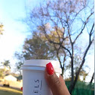
❤️3
Hemels Café (owner)
a year ago
Thank you for this kind review! We appreciate the feedback and will pass it on to our team.

Crizanne Grobler
Local Guide·40 reviews·15 photos

3 years ago
Lovely little coffee shop in Pretoria East.. would definitely visit again.
❤️2
Hemels Café (owner)
2 years ago
Thank you for your kind review Crizanne. We appreciate it and hope to see you again soon!

Grant Makhudu
2 reviews

3 years ago
Takeaway | Breakfast | R 50–100
Amazing service from staff & great coffee, would definitely recommend!
Order type: …More
❤️1
Hemels Café (owner)
3 years ago
Thank you very much for your kind review Grant. We hope to see you again soon!

Anode Odendaal
1 review

3 years ago
Liking the place. I like the old trees giving ample shade, underlining the rustic atmosphere.
❤️1
Hemels Café (owner)
3 years ago
Thank you very much for your kind review Anode. We hope to see you again soon!

joel mohlake
Local Guide·5 reviews·21 photos

2 years ago
Dine in | R 50–100
Best place to be at.. Very beautiful space and super friendly staff 👌👌👌
Order type: …More
❤️3

Lubel Balkwell
4 reviews·3 photos

2 years ago
Love this place. Beautiful setting. Love their products.
Food: …More
❤️2
Hemels Café (owner)
2 years ago
Thank you Lubel, for your kind review!

Christelle Dobie
1 review

2 years ago
Most delicious coffee freezos!
Lovely atmosphere!
Hemels Café (owner)
2 years ago
Thank you Christelle! We are delighted to hear this. Appreciate the kind review.

Sarah
Local Guide·157 reviews·45 photos

2 years ago
Nice hidden gem in PTA! Really good coffee and a nice vibe.
Food: …More
❤️2
Hemels Café (owner)
2 years ago
Thank you for your kind review Sarah! We appreciate it.

Caitlin Calitz
5 reviews

2 years ago
Dine in | Lunch
Lovely little place with friendly service and great treats.
Order type: …More
❤️2

Henré Jordaan
1 review

3 years ago
Love this place.Its the best service you could ever ask for...Shapies.
Hemels Café (owner)
3 years ago
⭐️⭐️⭐️⭐️⭐️

Elaine Luus
1 review·3 photos

3 years ago
The name speaks for itself!!!

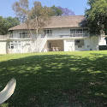
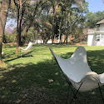
Hemels Café (owner)
3 years ago
⭐️⭐️⭐️⭐️⭐️ Wow Mrs Luus! Thank you for the review you left. Thank you for your support.

Wolfies Gaming
4 reviews·1 photo

a year ago
Dine in | Brunch | R 100–150
Awesome little place
Order type: …More
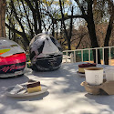
❤️2
Hemels Café (owner)
a year ago
Thank you for this kind review! We appreciate the feedback.

Jaco Oberholzer
Local Guide·182 reviews·19 photos

Edited 2 years ago
Growing nicely with different shops, nice coffee and cake, micro blading, bridal dresses, etc. …More
❤️1
Hemels Café (owner)
3 years ago
Thank you for your review Jaco!

Samantha de Hart
10 reviews

a year ago
Beautiful venue with amazing coffee!
Food: …More
❤️2
Hemels Café (owner)
a year ago
Thank you for leaving us this wonderful review Samantha!

Bruce Mogohlwane
1 review

9 months ago
Excellent customer service
Food: …More

Nikita RDS
5 reviews

3 years ago
Other | R 50–100
Great vibe, relaxing and great service.
Meal type: …More
❤️1
Hemels Café (owner)
3 years ago
Lovely! Thank you!

Motsei Mathobela
2 reviews

2 years ago
Dine in | R 100–150
Thandi nailed the service. Exceptionally well done.🥰🤗
Order type: …More
Hemels Café (owner)
2 years ago
Thank you Motsei! Thandi is an absolute superstar. Appreciate the review.

Stefan Rousseau
Local Guide·38 reviews·42 photos

2 years ago
Great little cafe with massive garden.
Food: …More
❤️2

Omolemo Job
3 reviews

2 years ago
Great staff, love the ambience :)
Food: …More
❤️2

Andries Grobbelaar
Local Guide·37 reviews·11 photos

3 years ago
way cool 😎
Atmosphere: …More
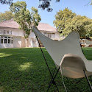
❤️1
Hemels Café (owner)
3 years ago
Thank you very much for your review Andries!

Harm Brouwer
Local Guide·74 reviews·13 photos

2 years ago
Brunch | R 100–150
Stunning under big shade trees
Meal type: …More
❤️1

Leon Moore
Local Guide·27 reviews·2 photos

2 years ago
Best coffee freezo in Pretoria!
Food: …More
❤️2

JJ van Tonder
Local Guide·15 reviews·187 photos

3 years ago
Takeaway | Other | R 50–100
Gr8, early morning coffee under the trees
Order type: …More
❤️2
Hemels Café (owner)
3 years ago
Thank you very much for your kind review!

Kiki Munaki
1 review

a year ago
The best place to be this winter !
Food: …More
❤️1

Wesley Cerff
Local Guide·4 reviews·16 photos

a year ago
Padel is great!!!
Service: …More

Ilana Smit
Local Guide·36 reviews·10 photos

a year ago
Dine in | Lunch | R 50–100
Is definitely "hemels"
Order type: …More
❤️2
Hemels Café (owner)
a year ago
Thank you Ilana! We appreciate your feedback.

Andrea Koekemoer
Local Guide·42 reviews·9 photos

2 years ago
Great little spot
Food: …More
❤️2

neville maloney
2 reviews·1 photo

2 years ago
Lovely place.
❤️2

Vertiblind Centurion
Local Guide·164 reviews·11 photos

2 years ago
Takeaway
☕😋
Order type: …More
❤️2

Makoma
1 photo

a year ago
Food:
Service: …More

Nico Grobler Bodyguards
Local Guide·437 reviews·887 photos

2 years ago
Dine in | Lunch | R 150–200
Order type:
Meal type: …More
❤️2

Matlhogonolo Tsae
6 reviews·1 photo

a month ago
R 100–200
Great and relaxed place
Price per person: …More


Ewald
1 review

3 years ago
Dine in | Lunch | R 150–200
This is the perfect place to take your family for a nice treat. They have the best coffee. …More
Hemels Café (owner)
3 years ago
Thank you very much.

Roger Jenkins
1 review

a year ago
People who eat milk are freaking delicious.
Food: …More
❤️2

Yvette Van Niekerk
Local Guide·81 reviews·392 photos

9 months ago
Service:
Atmosphere: …More
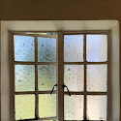
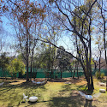
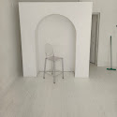
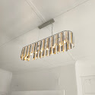
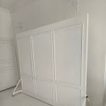

Simoné Jones
Local Guide·37 reviews·49 photos

3 years ago
Food:
Service: …More
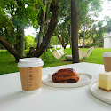
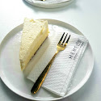
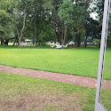
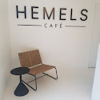
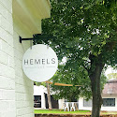
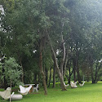
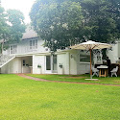
❤️1
Hemels Café (owner)
2 years ago
Thank you Simone! We appreciate your generous rating.

Maryke van der Watt
Local Guide·96 reviews·111 photos

2 years ago
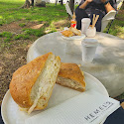
❤️1

Khuli Mlambo
2 photos

a year ago
Brunch | R 350–400
Meal type:
Price per person: …More
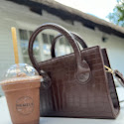
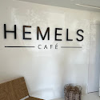
❤️1

Katlego Tshotlhang
3 reviews

3 months ago
Brunch | R 100–200
Meal type:
Price per person: …More
❤️1

Anntte Rohde
1 review

6 months ago
Food:
Service: …More
❤️1

Paul Grobler
Local Guide·57 reviews·216 photos

7 months ago
Other | R 100–200
Meal type:
Price per person: …More
❤️1

Ilse Lamoer
9 reviews

7 months ago
Food:
Service: …More
❤️1

Anje de Andrade
Local Guide·32 reviews·12 photos

8 months ago
Lunch | R 100–200
Meal type:
Price per person: …More

Kelebogile Malatji

9 months ago
Breakfast | R 100–200
Meal type:
Price per person: …More

Lunga Zondi

a year ago
Food:
Service: …More

corrie swarts
Local Guide·42 reviews·140 photos

a year ago
R 100–150
Price per person:
Food: …More

Prince Mahlangu
10 reviews

a year ago
Dine in | Other | R 100–150
Order type:
Meal type: …More

mpho magabotje

a year ago
Food:
Service: …More

Marina Slabbert

a year ago
Dine in | Other | R 200–250
Order type:
Meal type: …More

Michaela Meiring

a year ago
Food:
Service: …More

Elga van Zyl
4 reviews

a year ago
Takeaway | Breakfast | R 50–100
Order type:
Meal type: …More

Thandi Priscilla

a year ago
Food:
Service: …More

Beauty Nkomo

a year ago
Food:
Service: …More

Lerato Hair Clinic

a year ago
Dine in | Brunch | R 100–150
Order type:
Meal type: …More

Bernice B
Local Guide·62 reviews·6 photos

a year ago
Food:
Service: …More

Barbara Du Toit
9 reviews·2 photos

a year ago
Dine in | Other | R 50–100
Order type:
Meal type: …More

Lerato Ngwaile

a year ago
Food:
Service: …More

West
Local Guide·6 reviews·19 photos

a year ago
Dine in | Lunch | R 150–200
Order type:
Meal type: …More

Oratile Tanke
2 reviews·1 photo

a year ago
Food:
Service: …More

Koketso Rammutla
1 review

a year ago
Lunch | R 100–150
Meal type:
Price per person: …More

Nelani Rikhotso

a year ago
Food:
Service: …More

Lulama Ndlovu
3 reviews

a year ago
Food:
Service: …More

Neil Jansen van Vuuren
23 reviews·18 photos

a year ago
Dine in | Lunch | R 100–150
Order type:
Meal type: …More

Pierre van Dyk
Local Guide·5 reviews

a year ago
Takeaway | R 100–150
Order type:
Price per person: …More

Basetsana Maponya
21 photos

a year ago
Food:
Atmosphere: …More

Martin Potgieter
Local Guide·133 reviews·1794 photos

a year ago
Food:
Service: …More

kgosi mamaregane

a year ago
Food:
Service: …More

Kaboentle letoaba
2 reviews

a year ago
Food:
Service: …More

Christiaan Jansen
Local Guide·82 reviews·58 photos

2 years ago
Dine in | Other | R 50–100
Order type:
Meal type: …More
Hemels Café (owner)
a year ago
Thank you Christiaan for a lovely review!

Neo Makgatho
3 reviews

a year ago
Food:
Service: …More

Ilanka van der Merwe

a year ago
Takeaway | Brunch
Order type:
Meal type:

ronelrat
1 review

2 years ago
Food:
Service: …More

Frikkie Van Deventer
Local Guide·11 reviews

2 years ago
Food:
Service: …More

Nicohan Combrink
3 reviews·9 photos

Edited 2 years ago
Food:
Service: …More

Paulina Maponya
3 reviews

2 years ago
Food:
Service: …More

eaglewatchergaming
Local Guide·17 reviews·4 photos

2 years ago
Food:
Service: …More

bubu phele
1 review·1 photo

2 years ago
Lunch | R 100–150
Meal type:
Price per person: …More

Maddy Mutati
Local Guide·8 reviews·21 photos

2 years ago
Food:
Service: …More

Kobus Morris
1 review

2 years ago
Dine in | Breakfast | R 50–100
Order type:
Meal type: …More

Theuno de Bruin
2 reviews

2 years ago
Food:
Service: …More

Sunette Kruger
Local Guide·80 reviews·97 photos

2 years ago
Food:
Service: …More

Annelize Botha
Local Guide·16 reviews·53 photos

2 years ago
Food:
Service: …More

Arthur Godfrey
2 reviews

2 years ago
Food:
Service: …More
🙏5
Hemels Café (owner)
2 years ago
Thank you!

Rut Kotze
6 reviews·2 photos

2 years ago
Dine in | R 150–200
Order type:
Price per person: …More

DigiGrow Admin

2 years ago
Brunch | R 50–100
Meal type:
Price per person: …More
🙏5

1. LSWBS SYSTEMS
1 review

2 years ago
Food:
Service: …More
🙏5

Itumeleng Lehomo
2 reviews·8 photos

2 years ago
Dine in | Other
Order type:
Meal type: …More
🙏1
Hemels Café (owner)
2 years ago
Thank you for your kind review.

Lungelo Daweti

2 years ago
Food:
Service: …More
Hemels Café (owner)
2 years ago
Thank you for this kind rating!

Teno Group
3 reviews·1 photo

2 years ago
Food:
Service: …More
Hemels Café (owner)
2 years ago
Thank you for this kind rating!

Khomotso Tjiane

2 years ago
Food:
Service: …More
Hemels Café (owner)
2 years ago
Thank you for your fabulous rating, Khomotso!

Mpho Lerutla
2 reviews

2 years ago
Food:
Service: …More
Hemels Café (owner)
2 years ago
Thank you for this generous rating Mpho!

Charlotte Olivier
Local Guide·26 reviews·2 photos

2 years ago
Other
Meal type:
Hemels Café (owner)
2 years ago
Thank you for your kind rating, Charlotte!

David Prins`
Local Guide·8 reviews·29 photos

3 years ago
Food:
Service: …More
Hemels Café (owner)
2 years ago
Thank you David for your generous star rating!

Elsje Balzun
3 reviews

3 years ago
Food:
Service: …More
Hemels Café (owner)
2 years ago
Thank you Elsje for your generous star rating!

Anne-Lize Fick
Local Guide·33 reviews·44 photos

3 years ago
Atmosphere: …More
Hemels Café (owner)
2 years ago
Thank you for your generous rating. We appreciate it!

Amohelang Jane Khoboko
1 review

5 days ago
New
R 100–200
Price per person:
Food: …More

EDWARD Mokone
Local Guide·2 reviews

3 weeks ago
New

Natanya van der Westhuizen
Local Guide·28 reviews·62 photos

a month ago
R 200–300
Price per person:
Food: …More
❤️1

Derienn Naidoo
Local Guide·11 reviews·9 photos

2 months ago
Food:
Service: …More

Amelia Nel
1 review

8 months ago

Kealeboga Seichokelo
Local Guide·13 reviews·14 photos

a year ago

Sieg
Local Guide·33 reviews·4 photos

a year ago

Lindiwe Manzini
4 reviews

2 years ago

Johan-O “Johan O”
Local Guide·122 reviews·47 photos

2 years ago

Chanel Pretorius
Local Guide·16 reviews·14 photos

2 years ago

T-time

2 years ago

Phillip Smith
Local Guide·10 reviews·6 photos

2 years ago

Lizelle Goosen
Local Guide·14 reviews·29 photos

2 years ago

Faith Feldman
Local Guide·13 reviews

2 years ago

Michelle King Vosloo
Local Guide·8 reviews·20 photos

3 years ago
Hemels Café (owner)
2 years ago
Thank you Michelle for your lovely and generous rating!

Arend Roossien
Local Guide·6 reviews·5 photos

3 years ago
Hemels Café (owner)
3 years ago
Thank you for giving us your 5 stars!

Webster Garira
9 reviews·3 photos

3 years ago
Hemels Café (owner)
2 years ago
Thank you Webster! Hope to see you again soon.

Jaypels Fouché
Local Guide·10 reviews·17 photos

3 years ago
Hemels Café (owner)
2 years ago
Thank you very much for this generous star rating!

Heinrich Korff
2 reviews

3 years ago
Hemels Café (owner)
2 years ago
Thank you Heinrich for this very kind rating!

Emily Dorfling
Local Guide·61 reviews·24 photos

3 years ago
Hemels Café (owner)
2 years ago
Thank you Emily! We appreciate this review.

Hanelize Henrico
1 review

3 years ago
Hemels Café (owner)
2 years ago
Thank you very much Hanelize!

Dewald du Plessis
1 review

3 years ago
Hemels Café (owner)
2 years ago
Thank you very much Dewald!

Lulama Mpato
Local Guide·10 reviews·16 photos

2 months ago
Other | R 200–300
A peaceful pocket of happiness. Simple menu that ensures great execution.
Lovely staff. Definitely recommend it for a sunny day, throw, your book and their beautiful surroundings +great service. …More
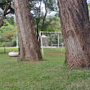

Evida Poopedi
Local Guide·21 reviews·104 photos

a year ago
Dine in | Brunch | R 100–150
The atmosphere is both aesthetically pleasing and refreshing, with a lovely nature-inspired vibe.
Their confectionery is great, but I was let down by their lentil soup. They …More

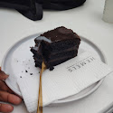
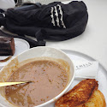
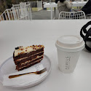
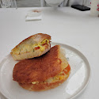

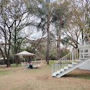
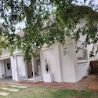

❤️2
Hemels Café (owner)
a year ago
Thank you for your feedback Evida. We will take it into account and always strive to improve. Happy to hear you still had a great experience.

sabina pauselli
Local Guide·25 reviews·8 photos

2 years ago
Dine in | Breakfast | R 100–150
We had a lovely experience. I love the outdoors area. The coffee was great, the ciabatta was delicious and the staff were friendly. …More
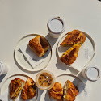
Hemels Café (owner)
2 years ago
Thank you Sabina. We appreciate your feedback.

Amelia Jacobs
3 reviews·3 photos

2 years ago
Takeaway | Brunch | R 100–150
Really enjoyed the vibe. Very cute and nice for a quick coffee and lunch with the friends.
The toasted sandwich I had was AMAZING! And the coffee was nice. The baristas …More
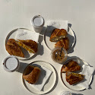

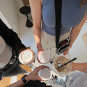
❤️2
Hemels Café (owner)
2 years ago
Thank you so much for your kind review Amelia!

Karla Kriel
Local Guide·24 reviews·132 photos

3 years ago
Dine in | Other | R 1–50
We had coffee here. The cappucino was really nice and had a unique taste. Would definitely recommend their cappucino. The atmosphere was also very nice and beautiful scenery …More
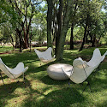

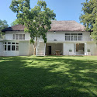
Hemels Café (owner)
3 years ago
Good day.
Thank you for the time you took to leave a review.
We highly appreciate your support.

NthabiLu
Local Guide·108 reviews·276 photos

a year ago
Dine in | Brunch | R 200–250
A very cute spot that is aesthetically appealing with a laid back atmosphere. Great service from Julius …More
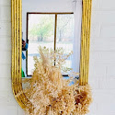
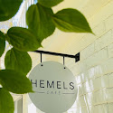
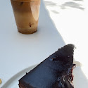
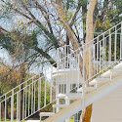
❤️2
Hemels Café (owner)
a year ago
Thank you for this kind review.

Kathryn Boman
Local Guide·24 reviews

8 months ago
A wonderful open space for family to picnic. Would recommend to anyone looking for a peaceful spot for little ones to run around and friends to catch up and chat. …More

Lee Joubert
Local Guide·35 reviews·33 photos

3 months ago
Breakfast | R 200–300
Always lovely to spend time under these lush trees, best barista!!
Meal type: …More
❤️1

Euliza Krog
11 reviews·7 photos

3 years ago
Dine in | Other | R 50–100
I took my sister in law to celebrate her 9 months to her wedding and we loved it! She really tought she were in heaven. It was her dream to have a coffee there. We had freezos and it was divine! …More
❤️1
Hemels Café (owner)
3 years ago
Thank you very much for your kind review. We are always working on improving our services and offerings so appreciate the feedback. We hope to see you again soon!

Jacque Esterhuizen
Local Guide·86 reviews·26 photos

3 years ago
Dine in | R 100–150
I just cant wait to go back. The most awesomestest coffee ever and the carrot cake was good. Its a self ordering setup but well worth it. Started out on nixe seating on the grass, then haf another cuppa up on the upstairs veranda. The view, …More
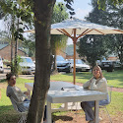
❤️2
Hemels Café (owner)
2 years ago
Hi Jacque! Thank you so much for this kind review. We are glad to hear you enjoyed our Hemels garden as much as we do! See you again soon.

Betsie Marais
Local Guide·73 reviews·2 photos

Edited 2 years ago
Dine in | Other | R 50–100
We liked the lovely trees and tranquility. They served us very friendly and the coffee was very good. We can recommend this very neat and peaceful place! …More
Hemels Café (owner)
2 years ago
Hi Betsie! Thank you for your kind review. We truly appreciate it and we are glad you had a good experience with us. See you again soon!

Louise van Heerden
Local Guide·36 reviews

2 years ago
Lovely venue in nature. Great staff and food.
The ' icecream day' was sadly very badly organised. It was an example of how not to do an event. …More
❤️2

Lance Nkosana Senda
5 reviews

2 years ago
Dine in | Lunch | R 100–150
Great place. Nice and outdoor. Perfect for some coffee and relaxation. Get the chicken Mayo, it's top tier. …More
❤️2

debbie van der merwe
Local Guide·27 reviews·9 photos

3 years ago
Dine in | Other | R 1–50
Friendly service. Informal picnic like setting. You can choose a place to sit under the trees, tables and chairs available. …More
❤️2
Hemels Café (owner)
3 years ago
Thank you Debbie. We appreciate your review!

Marie Botha
Local Guide·489 reviews·349 photos

11 months ago
Lovely atmosphere. Very.limited menu....self service

Kefentse Radebe
3 reviews

2 years ago
Dine in | Breakfast | R 100–150
Great outdoor place to hang out with friends. Absolutely loved it. Very esthetic as well …More
❤️2
Hemels Café (owner)
2 years ago
Thank you for your review Kefentse!

Belinda Engelbrecht
Local Guide·79 reviews·10 photos

2 years ago
Dine in | Other | R 50–100
Relaxing open area. Delicious Carrot cake! The carwash on the premises does an excellent job! …More
❤️2

Rene Wright
Local Guide·217 reviews·3654 photos

2 years ago
Tranquility greenery with huge trees. Lots of oxygen and lovely self order coffee , cakes and pastries. …More
❤️2

Johan Pieterse
Local Guide·499 reviews·507 photos

a year ago
Dine in | Other | R 1–50
Good coffee. Lovely under the trees
Order type: …More
❤️2
Hemels Café (owner)
a year ago
Thank you for your review Johan!

Luzelle van Niekerk
3 reviews

2 years ago
Friendliness of staff going extra mile with smallest orders 👌
Service: …More
❤️2
Hemels Café (owner)
2 years ago
Thank you Luzelle! Our staff truly is the best and we know they will appreciate your kind words.

Lerato Phaka
1 review

Edited 2 years ago
Dine in | Breakfast | R 100–150
Best Dirty Latte Ive ever had.
Order type: …More
Hemels Café (owner)
2 years ago
Thank you Lerato! We are so happy to hear this.

elly long
5 reviews

3 years ago
Other | R 50–100
Very peaceful environment for chat and coffee
Meal type: …More
❤️2
Hemels Café (owner)
3 years ago
Thank you very much for your kind review!

Anya Marais
Local Guide·144 reviews·67 photos

2 years ago
Lovely cafe with great coffee.
Food: …More
❤️2
Hemels Café (owner)
2 years ago
Thank you Anya! We are glad you enjoyed our coffee.

Eric Breedt
Local Guide·269 reviews·591 photos

3 years ago
Great coffee
Service: …More
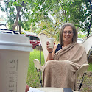

❤️2
Hemels Café (owner)
3 years ago
Thank you! We love seeing your photos. Appreciate the review.

Callie Fest
2 reviews

4 months ago
Breakfast | R 100–200
Meal type:
Price per person: …More
❤️1

Lillian Mongalo
2 reviews

5 months ago
Other
Meal type:
Food: …More
❤️1

Liezel Brummer
Local Guide·2 reviews

8 months ago
Breakfast | R 100–200
Meal type:
Price per person: …More

Kgomotso Dladla
Local Guide·32 reviews·186 photos

9 months ago
Food:
Service: …More

Wonderboompoort CIMAC

a year ago
Other | R 100–150
Meal type:
Price per person: …More

DM Photograpic
Local Guide·19 reviews·78 photos

a year ago
Food:
Service: …More

Letetia Moller
Local Guide·22 reviews·6 photos

a year ago
Food:
Service: …More

Johan Delport
Local Guide·224 reviews·71 photos

2 years ago
Dine in | Lunch | R 200–250
Order type:
Meal type: …More

Thabiso Grace
Local Guide·5 reviews·3 photos

2 years ago
Dine in | Brunch | R 300–350
Order type:
Meal type: …More

Farai Douglas
Local Guide·1 review

2 years ago
Food:
Service: …More

Crystal Munthree
Local Guide·12 reviews·8 photos

2 years ago
Dine in | Brunch | R 50–100
Order type:
Meal type: …More

Jeane Lourens
Local Guide·16 reviews·1 photo

2 years ago
Food:
Service: …More

Elsabe Buitendach
Local Guide·28 reviews·4 photos

2 years ago
Dine in | Lunch | R 50–100
Order type:
Meal type: …More

Mulalo Makhado
3 reviews

2 years ago
Food:
Service: …More

zandile Mathebula
Local Guide·12 reviews·6 photos

2 years ago
Dine in | Brunch | R 100–150
Order type:
Meal type: …More

Hannelie Vosloo
Local Guide·63 reviews·39 photos

2 years ago
Other
Meal type:
Service: …More

Trevor Thompson
Local Guide·7 reviews·6 photos

2 years ago
Food:
Service: …More
🙏1

Etrecia Groenewald
2 reviews

2 years ago
Dine in | Lunch | R 100–150
Order type:
Meal type: …More
🙏1
Hemels Café (owner)
2 years ago
Thank you for your kind review!

Tanna Baker
1 review

2 years ago
Dine in | Brunch | R 100–150
Order type:
Meal type: …More

OJK Huawei
5 reviews

3 years ago
Dine in | Other | R 1–50
Order type:
Meal type: …More
Hemels Café (owner)
2 years ago
Thank you for your star rating!

Carlo Rheeder
Local Guide·4 reviews

3 years ago
Dine in | Other | R 50–100
Order type:
Meal type: …More
Hemels Café (owner)
2 years ago
Thank you Carlo for your star rating!

Hanre Erasmus
Local Guide·21 reviews

3 years ago
Dine in | Other | R 150–200
Order type:
Meal type: …More
Hemels Café (owner)
2 years ago
Thank you for your star rating!

Mkhululi Ndlovu

a month ago
Breakfast | R 100–200
Meal type:
Price per person: …More

Gerda Craig
Local Guide·21 reviews·126 photos

a month ago
R 100–200
Price per person:
Food: …More

Dominique Geyser
Local Guide·8 reviews·6 photos

a year ago

Matthew Eardley
5 reviews

a year ago

chantel jordaan
4 reviews

2 years ago

Phillip Smal
5 reviews

2 years ago

Robyn Knox
Local Guide·10 reviews

2 years ago

Ronnie Potgieter
1 review

2 years ago

Jacques Human
3 reviews

2 years ago

Lisa Smith
Local Guide·34 reviews·18 photos

2 years ago
Hemels Café (owner)
2 years ago
Thank you for this rating!

Annalien Esterhuizen
9 reviews

3 years ago
Hemels Café (owner)
2 years ago
Thank you Annalien for your feedback.

Maryna Verwey
2 reviews·3 photos

6 months ago
Breakfast | R 100–200
I ordered a Cheesy Harvest Ciabatta. There was literally just one piece of tomato and a tiny bit of cheese that you could hardly identify as cheddar and mozzarella and no onion. The coffee however was very good! …More
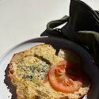
🔥1

Ané Visser
Local Guide·19 reviews·148 photos

a year ago
R 100–150
Lovely atmosphere.
One padel court to play on. …More

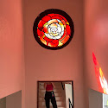
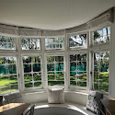
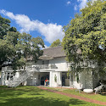
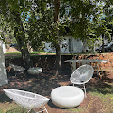
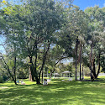

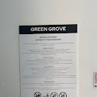
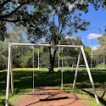
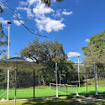
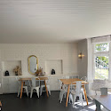
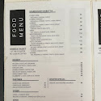
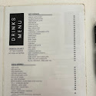
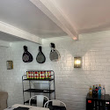
❤️1

Jennie De Jager
Local Guide·19 reviews·7 photos

a year ago
The place is stunning.
Atmosphere is great. …More
❤️1
Hemels Café (owner)
a year ago
Good day Jennie
Thank you for taking the time to talk with us in person as we continue to improve our overall experience and offering.
We on most occasions reach out to customers directly to attend to any complaints. We appreciate your constructive criticism and will continue to improve our customer’s experience as much as we possibly can.

The Cardinal
Local Guide·16 reviews·4 photos

a year ago
I'm a regular at Hemels Cafe, and my friends and I love meeting there for coffee. We decided to host a combined birthday celebration there on February 15th. I booked the event with Danika on January 22nd, and we agreed on the details, …More
❤️1
Hemels Café (owner)
a year ago
Dear Hanli,
Thank you for your feedback. We appreciate you choosing to celebrate with us and are always happy to accommodate special requests when possible.
Regarding your concern about the table setup, our event services—including pre-set tables—are reserved for customers who opt for our event package, which includes an event fee. Our free table reservations option does not include table setup or “event” privileges etc. As a courtesy, we gladly accommodated your request to bring outside champagne and cake, as we strive to make special occasions enjoyable within our policies.
We also want to emphasize that our staff works hard to provide excellent service to all guests. While we understand and apologise for misunderstandings and expectations not being met, we kindly ask that all interactions remain respectful and kind. Other clients from our studios above could not help but hear the shouting and use of harsh language towards our staff. Our team is always happy to assist, and we believe that kindness and professionalism go both ways.
If you have any further questions, we are happy to clarify our policies. We appreciate your understanding and hope to welcome you again in the future. We will investigate the matter more closely with our team in the meantime and see where improvements can be made.
Have a good weekend.

ken halland
Local Guide·40 reviews·12 photos

10 months ago
R 1–50
Good coffee and friendly service. Facilities are otherwise fairly rudimentary.
Price per person:

winky mashaya
1 review

a year ago
Dine in | Brunch
I had my car stolen here on the 12.04.2025 while I was attending a baby shower and that really ruined my experience. …More

Chris Basson
Local Guide·11 reviews·13 photos

2 years ago
Nice but it really caters for stop-n-go, I'm not overly impressed by the lawn chairs available. Coffee is good though 👍 …More
❤️1
Hemels Café (owner)
2 years ago
Hi Chris. Thank you for your feedback. We are sorry we couldn’t meet your expectations.

Gideon Munnik
Local Guide·5 reviews

a year ago
Dine in | Breakfast | R 100–150
Poor wifi experience for remote working
Order type: …More
❤️1
Hemels Café (owner)
a year ago
Hi Gideon
Thank you for your feedback. We will work on improving our wifi connection.

Skye Tarryn Steele
Local Guide·24 reviews·21 photos

3 years ago
Food was not fresh.
Food: …More
Hemels Café (owner)
3 years ago
Good day Ms Steele.
We’re sorry to hear about your bad experience.
We value your feedback.
Please send us a WhatsApp to 083 379 0086 so that we can make it up to you.

Mariette van Niekerk
Local Guide·108 reviews·109 photos

2 years ago
Beautiful gardens
Service: …More
❤️1

Ellie C
Local Guide·88 reviews·868 photos

Edited 2 years ago
Takeaway | Other | R 1–50
Order type:
Meal type: …More
❤️2

COPYWRITING REQUIREMENTS

The copy must follow a suitable high-converting copywriting framework chosen specifically for this business.

Analyse:
- the Google reviews
- local coffee shop best practices
- hospitality conversion principles
- local search intent
- emotional buying drivers

Then choose the most suitable framework and apply it consistently throughout the page structure and flow.

You are also an editor with a sharp eye for writing that reads built, not performed.

Write naturally. Cut anything that sounds rehearsed, over-polished, corporate, or like it is trying too hard.

The writing should move like a real mind:
- punchy in places
- slower in others
- uneven where appropriate
- occasionally breaking perfect grammar naturally
- confident without sounding scripted

Own the positioning through the writing.

Break patterns when the writing starts feeling too controlled or predictable.

Remove:
- typical AI phrasing
- repetitive sentence rhythms
- “not X but Y” constructions
- startup jargon
- empty branding language
- fake warmth
- over-explaining
- three-part fragment patterns
- generic coffee shop clichés

The tone should feel:
- warm
- confident
- independent
- soulful
- local
- slightly rebellious
- understated
- premium but approachable

The copy should not try to please everyone.

Allow:
- opinions
- contrast
- subtle contradictions
- tonal shifts
- personality
- restraint

The writing should land emotionally when someone reads it.

Suggest a suitable page structure, using this as a starting point:
PAGE STRUCTURE

1. Hero section
Communicate:
- what it is
- where it is
- who it is for
- why it is different
- the feeling of being there

Include:
- strong headline
- short subheadline
- primary CTA
- secondary CTA
- trust line from reviews

Avoid generic headlines like:
“Welcome to ”
“Your local coffee shop”
“Great coffee, great people”

2. Why locals come here
Use review insights to explain:
- atmosphere
- coffee quality
- service
- food
- music or vibe
- reasons people come back

3. Coffee, food, and atmosphere highlights
Create simple highlight cards for:
- coffee
- breakfast or light meals
- pastries or treats
- atmosphere

Use placeholders where details are missing.

4. Review-led trust section
Create testimonial cards using the reviews.

Rules:
- do not invent reviews
- use real wording where possible
- otherwise paraphrase honestly

5. Email capture section
Create a strong email signup section.

Choose a strong positioning suitable for this brand:
“Get first notice of special offers, limited coffee specials, and small local events before they fill up.”

Include:
- first name field
- email field
- submit button
- privacy reassurance
- JavaScript success message
- placeholder for real email platform integration

The signup should feel like joining the culture of the coffee shop, not a generic newsletter.

7. Visit us section
Include placeholders for:
- address
- opening hours
- phone or WhatsApp
- Instagram
- Google Maps embed
- parking details

8. FAQ section
Create SEO-friendly and AI-search-friendly FAQs such as:
- Where is it located?
- What kind of coffee shop is it?
- Do you serve food or breakfast?
- Are you open weekends?
- How do I hear about events or specials?

Answers should be clear, local, natural, and easy for AI tools to extract, add in relevant FAQs to aid AI search.

9. Final CTA section
End with a warm but direct CTA encouraging visitors to:
- visit the shop
- join the email list
- follow on Instagram

SEO + AI SEARCH REQUIREMENTS

Optimise for:
- Google local search
- ChatGPT
- Perplexity
- Gemini
- Google AI Overviews

Use:
- semantic HTML5
- strong heading structure
- local keyword phrasing
- concise crawlable text
- natural language answers
- FAQ schema
- LocalBusiness/Cafe schema
- optimised title tag
- meta description
- Open Graph tags
- internal anchor links
- image alt placeholders
- clear NAP placeholders
- Hilton and Pietermaritzburg references

The page should help rank for local searches like:
- coffee shop in [place]
- best coffee in [place]
- coffee shop [place]
- breakfast and coffee in [place]
- cosy coffee shop near me

DESIGN + MOBILE LEGIBILITY REQUIREMENTS

All text must be designed for excellent readability on mobile.

Use:
- strong colour contrast
- readable font sizes
- comfortable line-height
- clear spacing
- accessible CTA buttons
- large tap targets
- readable forms
- clear visual hierarchy

Avoid:
- tiny text
- low-contrast text
- text over busy textures without overlays
- cramped layouts
- oversized headings on mobile

Prioritise clarity over decoration.

Before finalising the HTML, internally check:
- mobile readability
- accessibility
- contrast
- button usability
- form usability
- testimonial readability
- FAQ readability
- responsive scaling

EMAIL CAPTURE FUNCTIONALITY

Include front-end JavaScript that:
- validates inputs
- shows a success state
- does not reload the page

Include clear comments showing where a real form integration can be added later:
- Mailchimp
- Brevo
- Formspree
- Netlify Forms
- or another platform

OUTPUT REQUIREMENTS

Return one complete HTML file only.

Include all:
- HTML
- CSS
- JavaScript

Do not include explanations outside the code.

Use clean, well-commented, editable code.

Use placeholder image blocks and placeholder business details where needed.

At the top of the HTML file, include a short comment block analysing the reviews and summarising:
- top customer praises
- strongest trust signals
- positioning angle
- best CTA angle
- strongest SEO phrases
- chosen copywriting framework and why it fits the business

